***Project Olympics***

**Step 1 : create database Projects;**

use Projects;

create table Olympics

(

ID int,

Name varchar(500),

Sex varchar(500),

Age int,

Height int,

Weight int,

Team varchar(500),

NOC varchar(500),

Games varchar(500),

Year int,

Season varchar(500),

City varchar(500),

Sport varchar(500),

Event varchar(500),

Medal varchar(500)

);

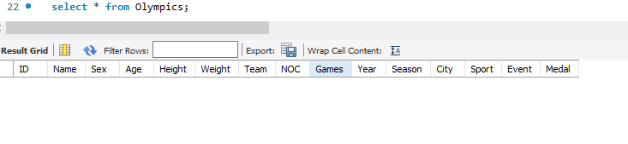

**Step 2:This path use show drive path**

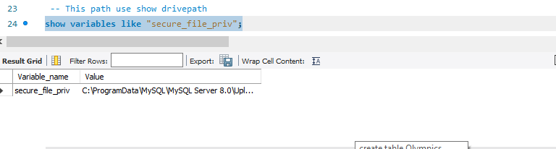

**Step 3: How to load data in SQL Server in CSV File**

load data infile"C:\\ProgramData\\MySQL\\MySQL Server 8.0\\Uploads\\Athletes_Cleaned.CSV"

into table Olympics

fields terminated by ","

enclosed by '"'

lines terminated by "\r\n"

ignore 1 rows;

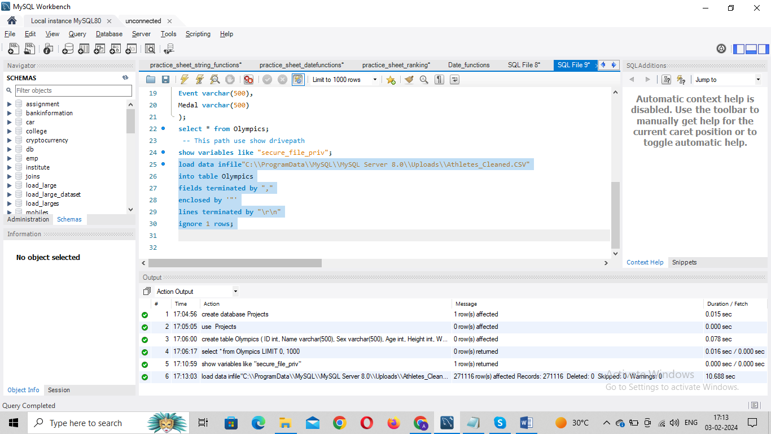

**Step 4: Show Table**

select * from Olympics;

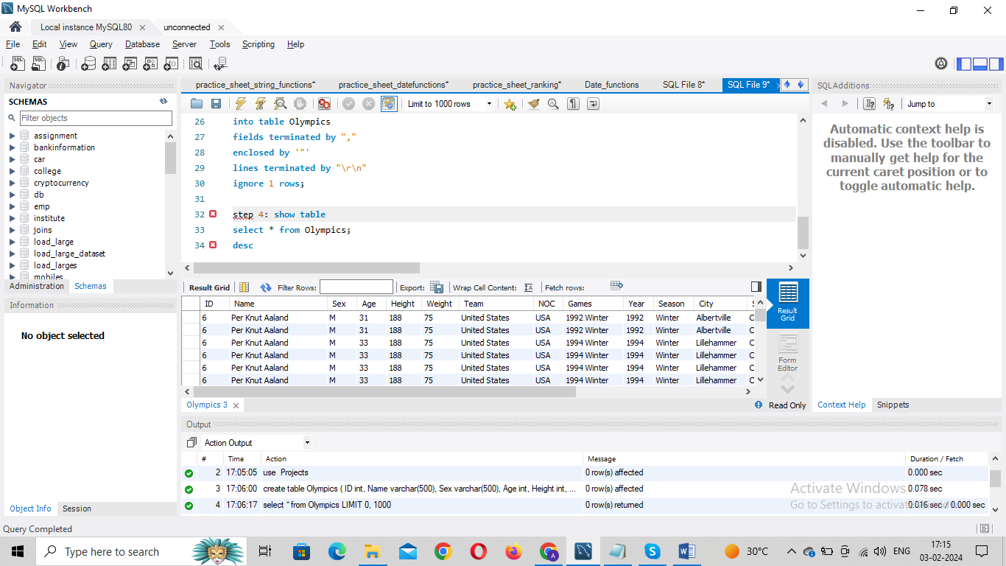

**Q1. Show how many medal counts present for entire data.**

select count(medal)

as Medal_Count,Medal from olympics

group by medal;

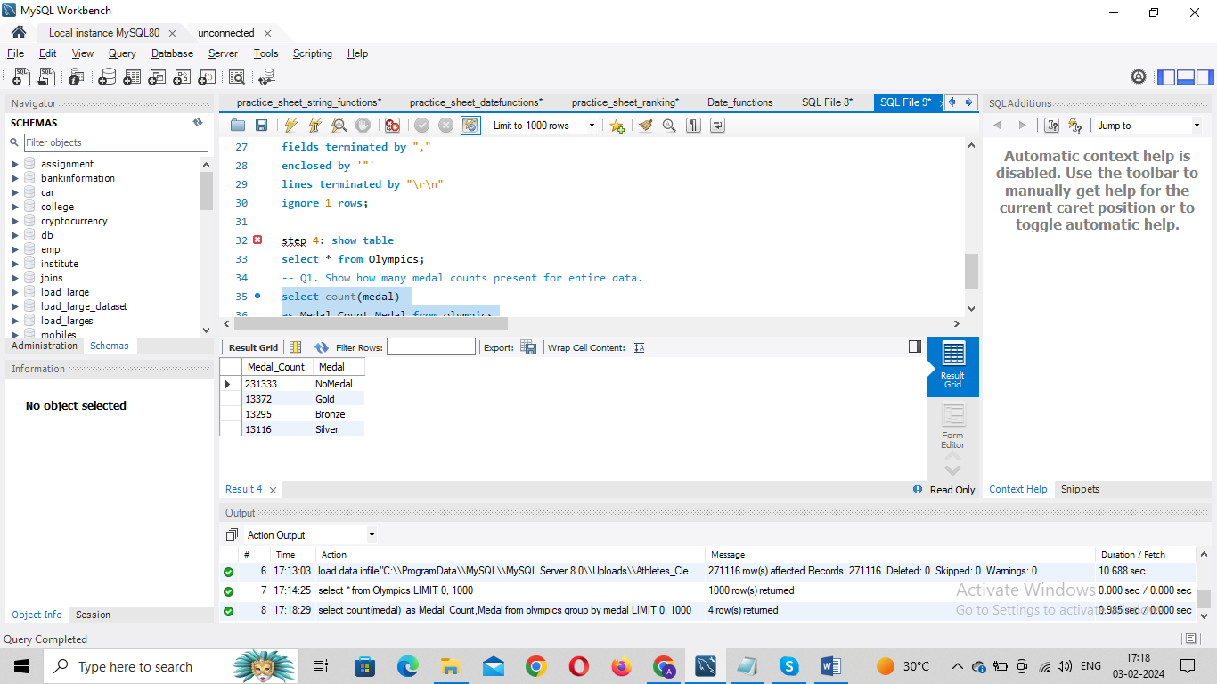

**Q2. Show count of unique sports present in Olympics.**

Select count(distinct(Sport)) as Count_of_Sports from olympics;

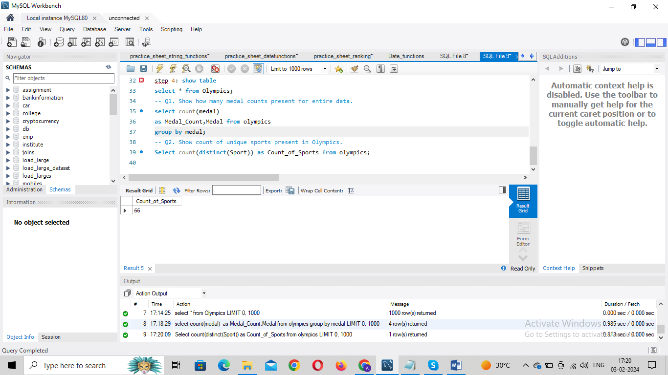

**Q3. Show how many different medals won by team India.**

select Team,Medal,count(Medal) from olympics

where (Team = 'India' and Medal!='NoMedal')

group by medal;

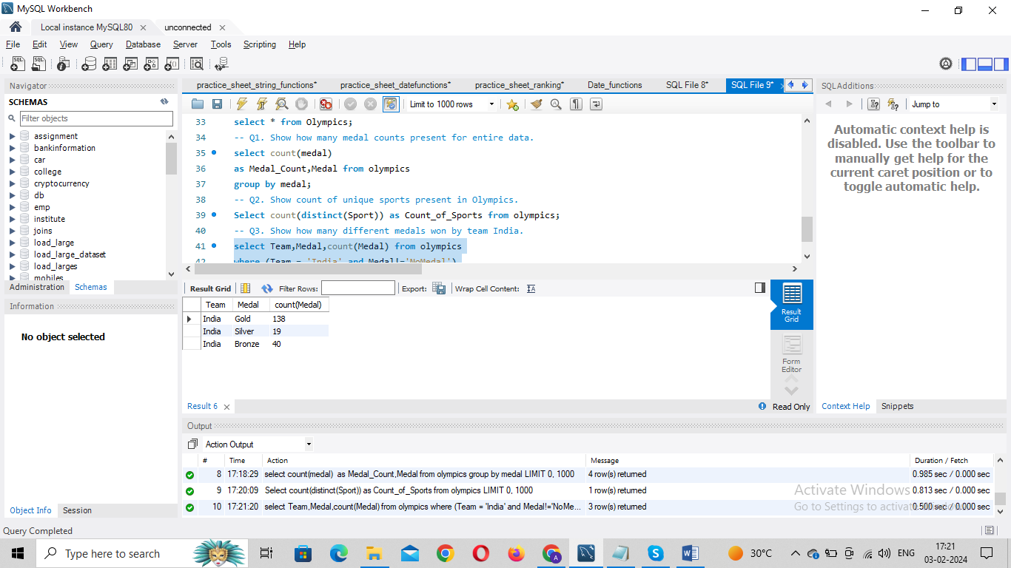

**Q4. Show event wise medals won by India show from highest to lowest medals won in order.**

select Team, count(Medal) as MedalCount,Event from olympics

where (Team = 'India' and Medal<>'NoMedal')

group by Event

order by MedalCount desc;

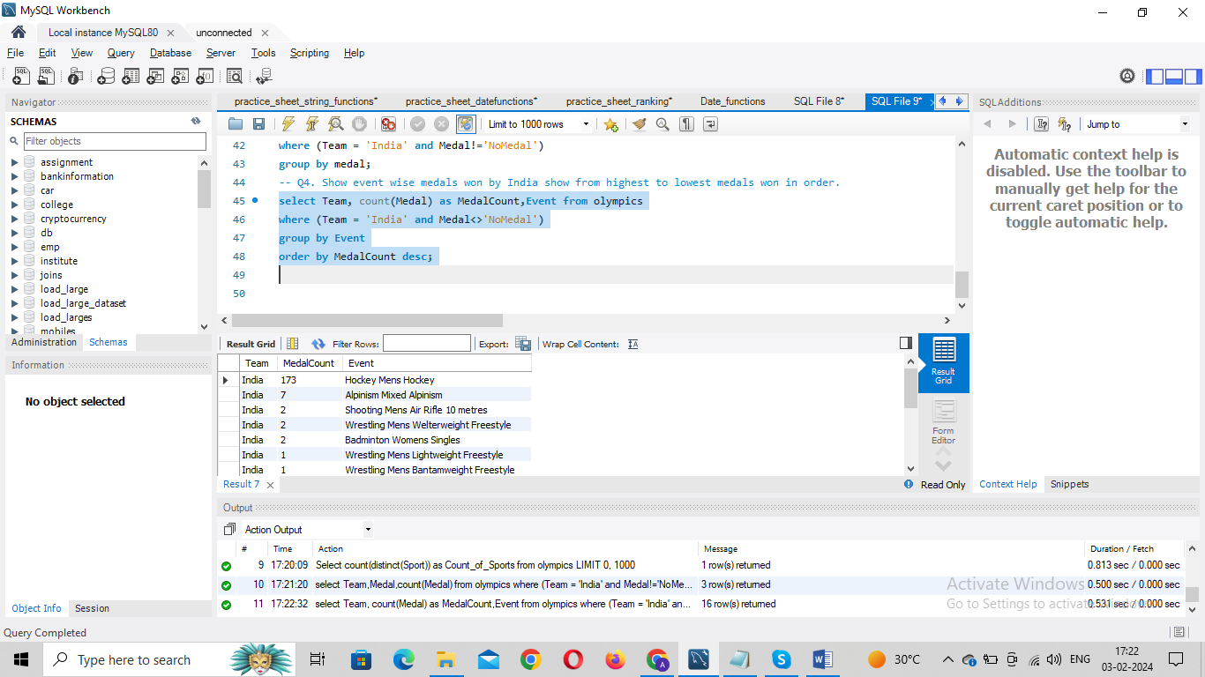

**Q5. Show event wise medals won by India in order of year.**

Select Team, Count(Medal) as MedalCount,Event,Year from olympics

where (Team = 'India' and Medal<>'NoMedal')

group by event,YEAR

order by Year asc;

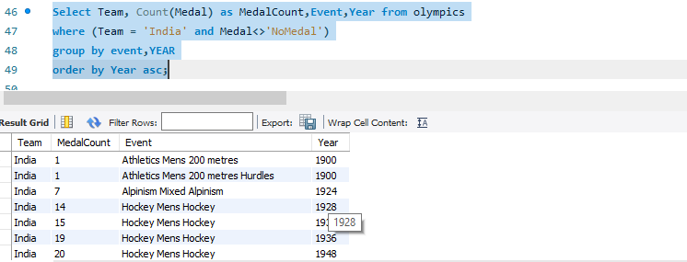

**Q6. show country who won maximum medals.**

Select Team,Count(Medal) as MedalCount from olympics

where Medal<>"NoMedal"

Group by Team

order by MedalCount desc

limit 1;

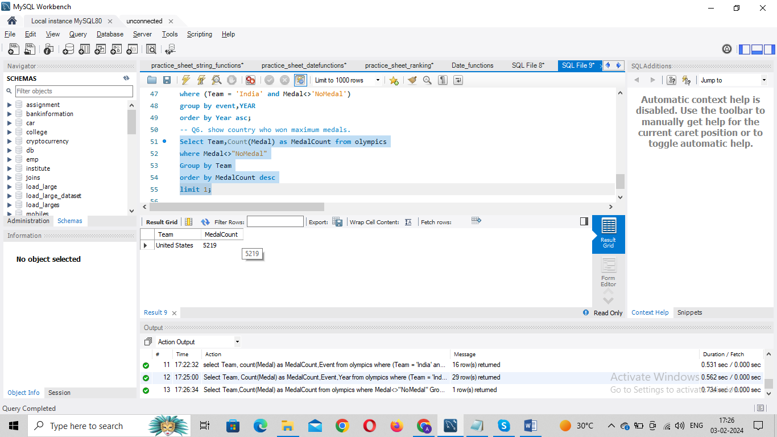

**Q7.show top 10 countries who won Max Medal**.

Select Team,count(Medal) as MedalCount from olympics

where Medal<>"NoMedal"

group by Team

order by MedalCount desc

limit 10;

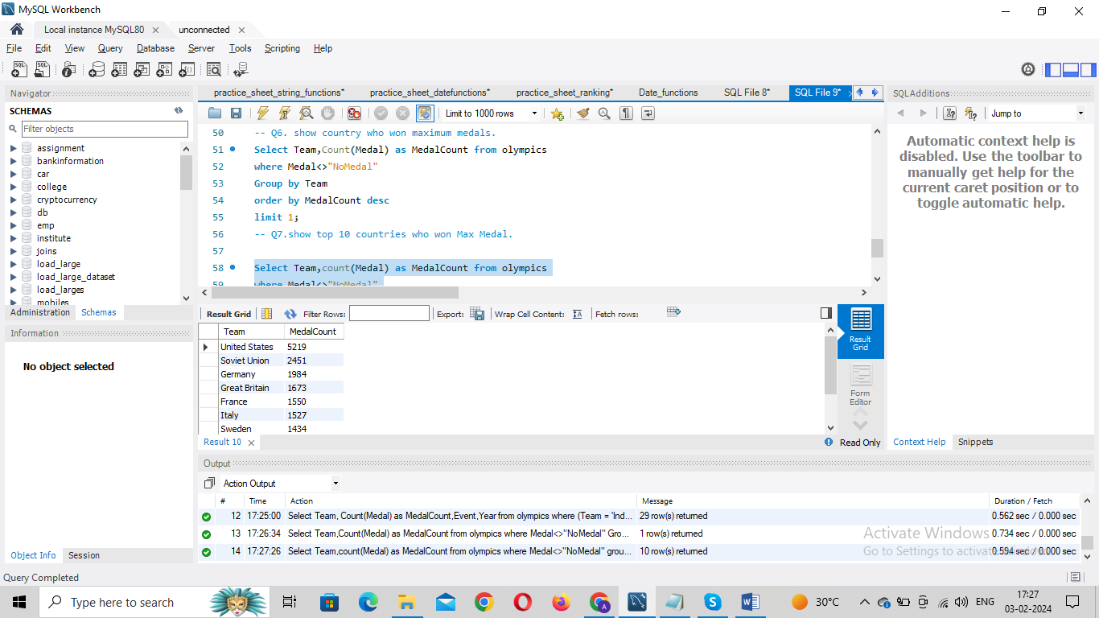

**Q8. show in which year did United states won most gold medal.**

Select Team,Count(Medal),Year from olympics

where (medal<>"NoMedal" and Team = 'United States')

Group by Year

order by count(Medal) desc

limit 1;

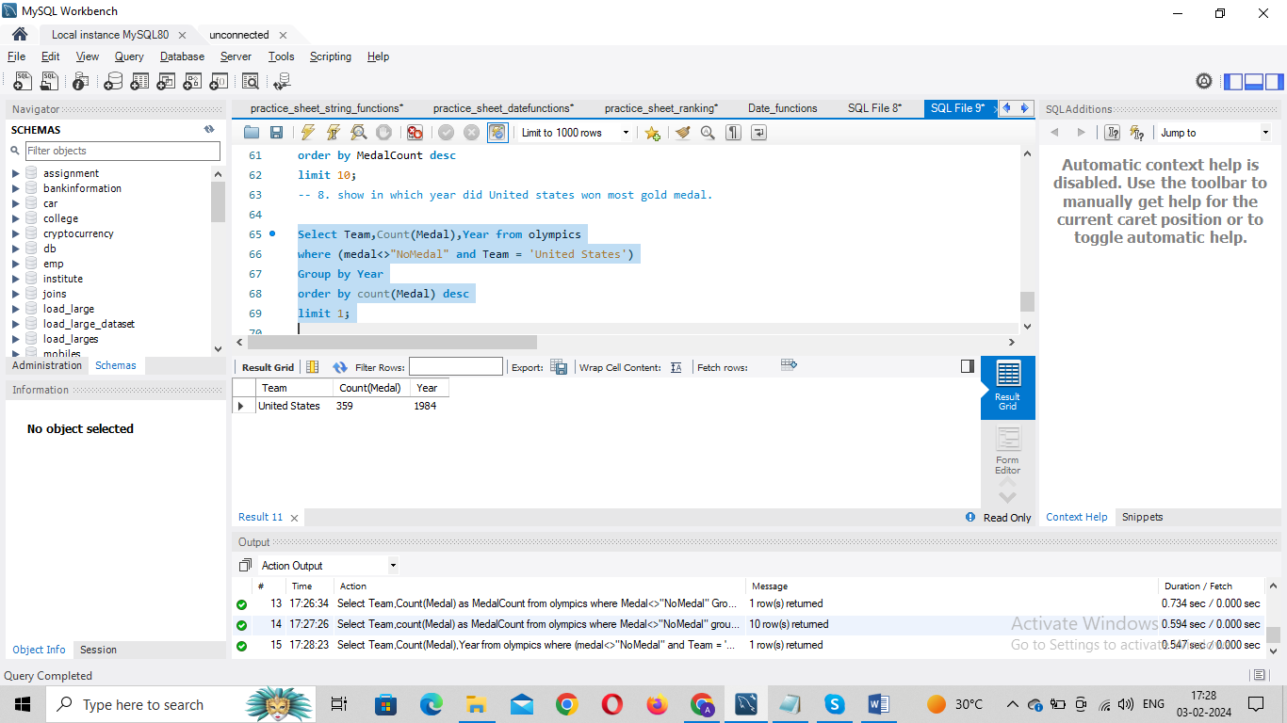

**Q9. In which sports United States has most medals.**

Select Team, Count(Medal) as MedalCount, Sport from olympics

where (Team = 'United States' and Medal<>'NoMedal')

group by Sport

order by MedalCount desc

limit 1;

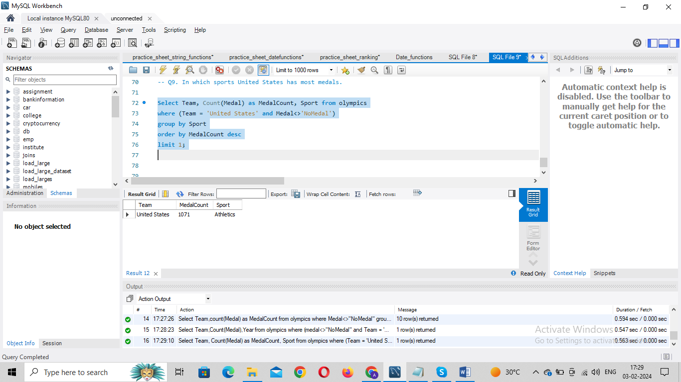

**Q10. Find top three players who won most medals along with their sports and country.**

Select Name, Team, Sport, count(Medal) from olympics

where Medal<>'NoMedal'

GROUP BY Name,Sport,Team

order by count(Medal) desc

limit 3;

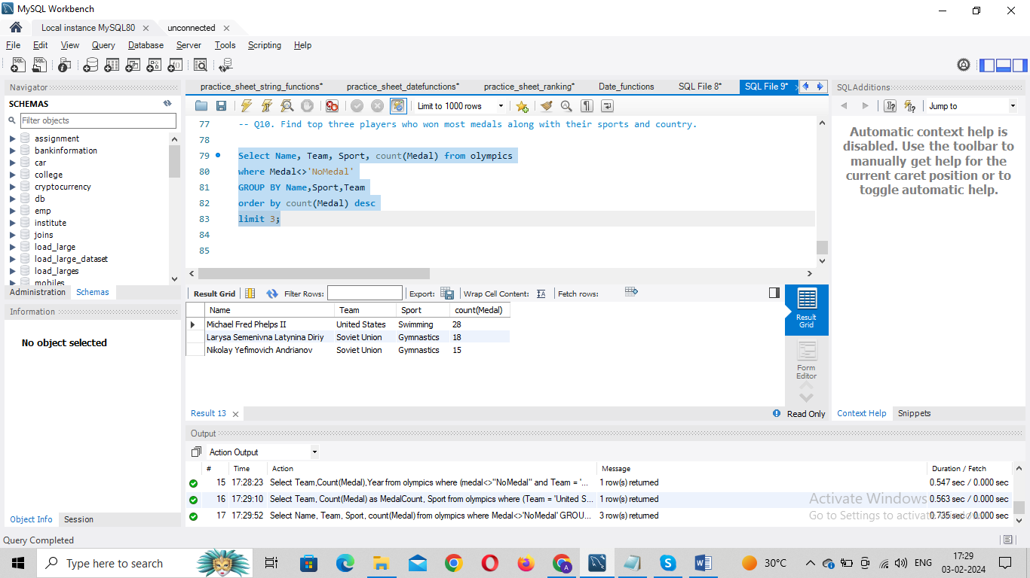

**Q11.Find Top 7 players with most medals (Gold+Silver+Bronze) in Basketball also show their country.**

Select Name,Team,Sport, count(Medal) from olympics

Where sport = 'Basketball' and Medal<>'NoMedal'

Group by Name,Team,Sport

order by count(Medal) desc

limit 7;

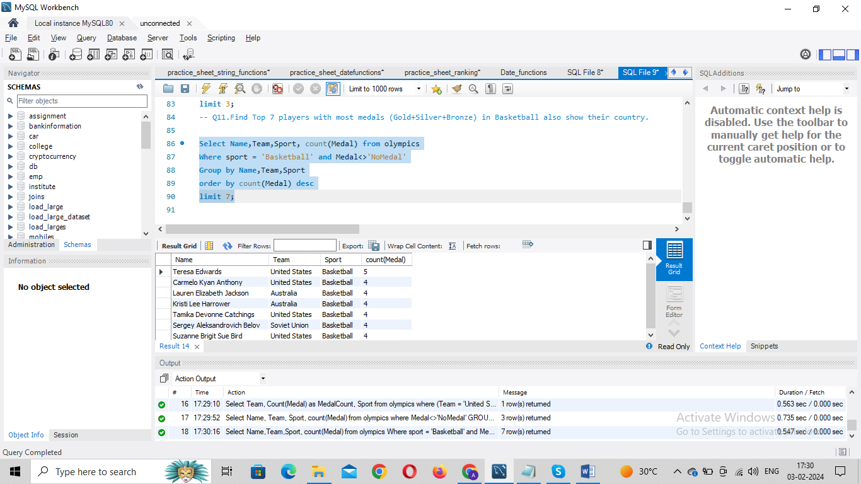

**Q12. Find out the count of different medals of the top basketball player Teresa Edwards.**

Select Name, Medal,count(Medal) as MedalCount from olympics

where Name = 'Teresa Edwards' and Medal<>'NoMedal'

group by Medal

order by MedalCount desc

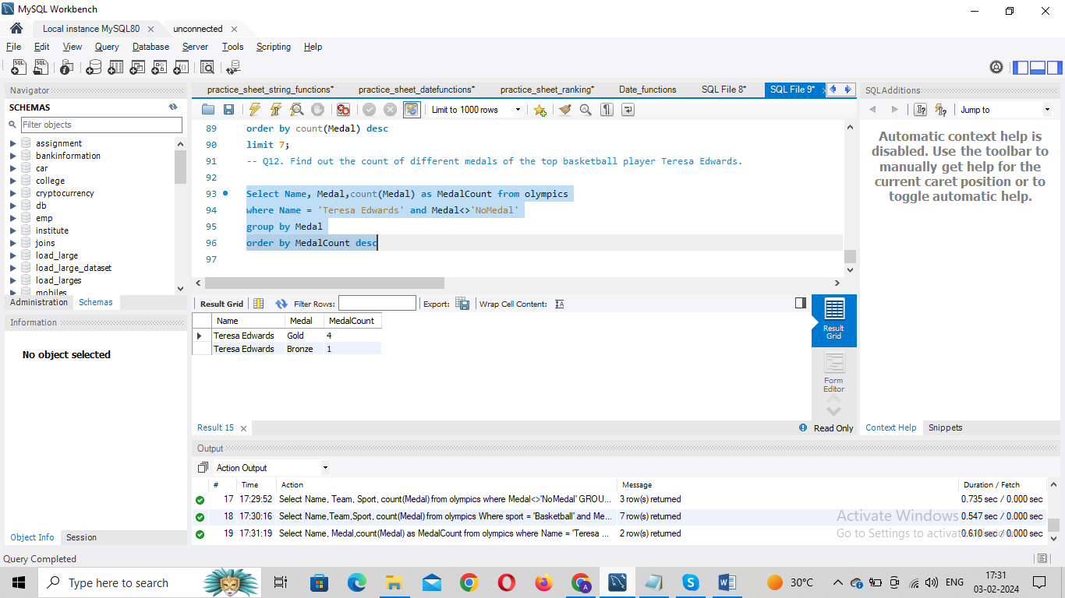

**Q13. Find out medals won by male,female each year.**

Select Year,Sex,Count(Medal) As MedalCount from olympics

Where medal<>'NoMedal'

Group by Sex,Year

order by Year asc;

